**Name**:Alaa Ahmed Mohamed Al-Rahi Mostafa

**B.N/**1085

**Date**: 10-6-2021

**Topic**: Internet Of Things

**Application Brief**: I chose this topic because its applications are the most used in the world

**GitHub-Link:**

https://github.com/Alaa21173/Internet-Of-Things-Alaa-Ahmed-Mohamed-Al-Rahi-Mostafa

**GitHub-Page(Published Website):**

<https://alaa21173.github.io/Internet-Of-Things-Alaa-Ahmed-Mohamed-Al-Rahi-Mostafa/>

**Screenshots**:

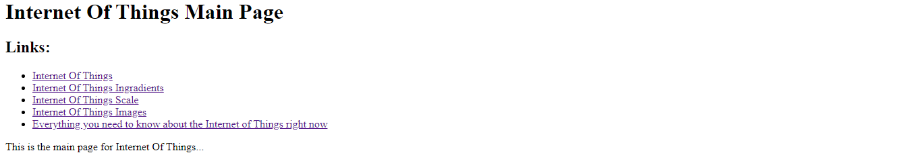

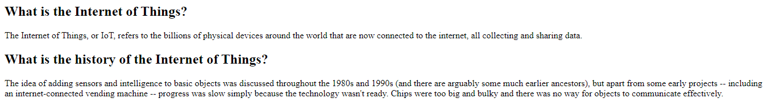



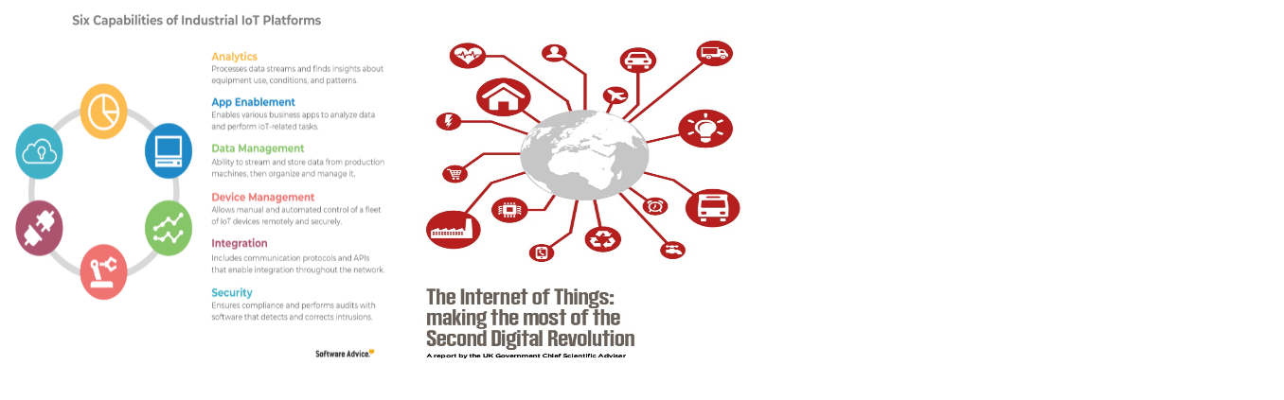

**Source Code**:

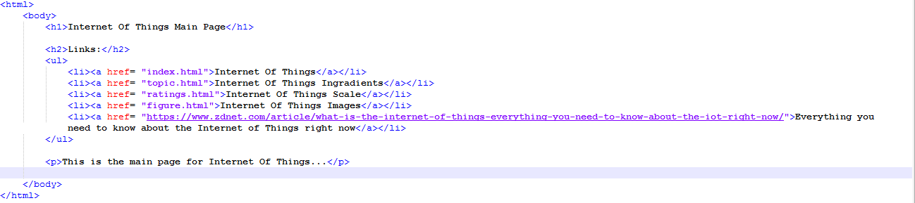

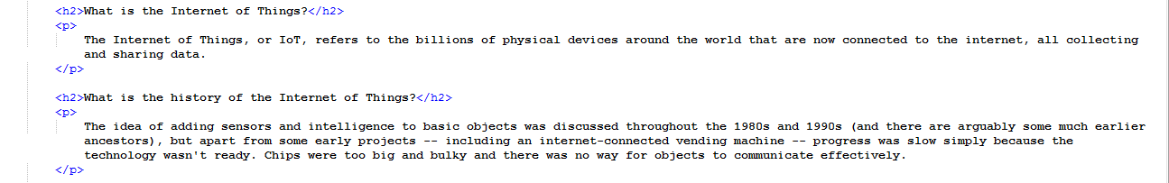

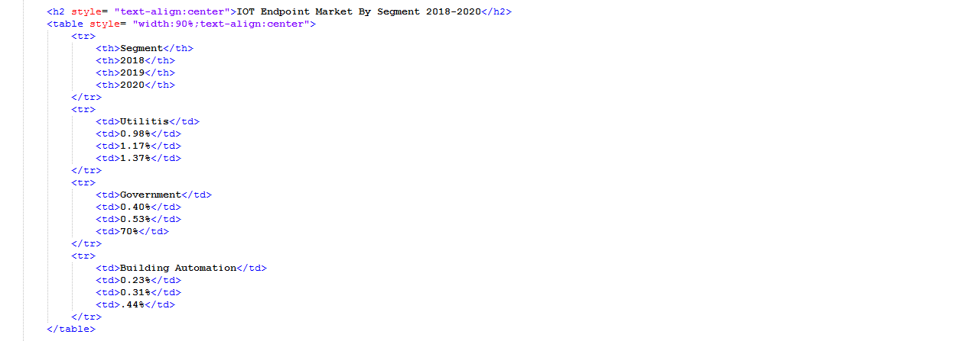

8